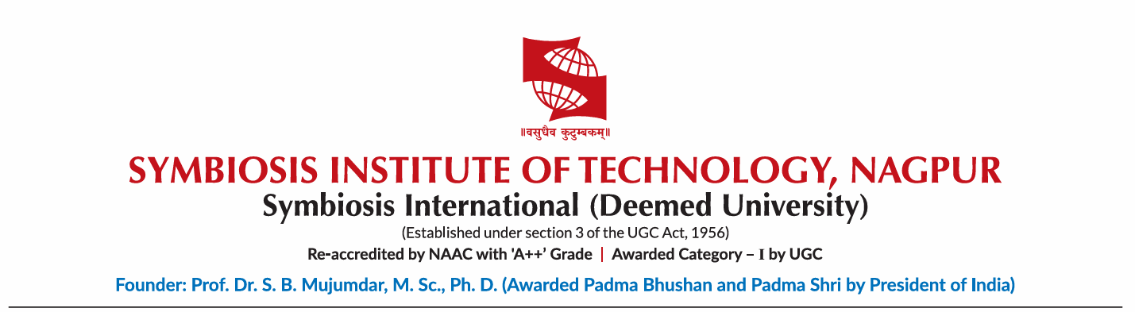

ONE MONTH INTERNSHIP REPORT

Submitted
By

Ayush Mahajan

Semester: Vth
Section: A
PRN: 23070521027

at

ServiceNow

JULY 2025

Declaration

I hereby declare that the Industry Internship Report submitted herein has been carried out by me in ServiceNow as part of the One-Month Internship.
This report is a true and accurate representation of the tasks performed, knowledge gained, and experiences acquired during the internship period. It reflects my individual effort, understanding, and involvement in the assigned activities.
I confirm that the contents of this report are original and authentic, and no part of it has been copied or reproduced from any other report or document without proper citation.
Any content sourced from references, manuals, websites, or other external materials is duly acknowledged in the report.

Name of Student: Ayush Mahajan
PRN: 23070521027
Date: 20th July 2025
Signature:

Verified by Class In-charge
Name of class In-Charge
Signature:

ACKNOWLEDGEMENT

I would like to express my sincere gratitude to ServiceNow for providing me with the opportunity to complete my internship in System Administration and gain valuable industry experience. This internship has been a highly enriching journey, helping me develop both technical and professional skills.
I am deeply thankful to my mentor/supervisor, ServiceNow, for his/her constant guidance, insightful feedback, and encouragement throughout the internship. Their expertise and support played a crucial role in enhancing my learning experience. I also extend my appreciation to my colleagues and team members at ServiceNow for their cooperation, assistance, and for making my internship a pleasant and productive experience.
I am immensely grateful to my academic institution, Symbiosis Institute of Technology, Nagpur for facilitating this internship opportunity. I extend my heartfelt appreciation to Dr. Nitin Rakesh, Director of Symbiosis Institute of Technology, Nagpur, for his continuous support and encouragement in providing students with industry exposure. I would also like to extend my deepest gratitude to Dr. Sagarkumar S. Badhiye, Head of the Department Computer Science and Engineering, Nagpur, for his constant support, encouragement, and invaluable guidance throughout my learning experience.

Thank you all for your invaluable contributions to my learning and professional growth.

Name of Student: Ayush Mahajan
PRN: 23070521027
Signature:

ABSTRACT

I gained hands-on experience with a top digital workflow and service management platform during my month-long internship at ServiceNow. Completing the "Micro-Certification: Welcome to ServiceNow" course, investigating different modules, and understanding incident and task management in the ServiceNow environment comprised my main project. My technical skills, professional abilities, and understanding of modern SaaS platforms and their use in the industry were all improved by this experience. The tasks completed, abilities learned, difficulties faced, and general insights obtained are described in this report.

TABLE OF CONTENTS

DECLARATION II
ACKNOWLEDGEMENT III
ABSTRACT IV
1. INTRODUCTION 1
2. OBJECTIVES OF THE INTERSHIP 1
3. COMPANY PROFILE 2
4. INTERSHIP ACTIVITIES 2
5. SKILLS LEARNED 3
6. CHALLENGES FACED 4
7. CONTRIBUTIONS TO THE ORGANIZATION 4
8. LEARNING OUTCOMES 5
9. CONCLUSION 6

1. INTRODUCTION

1.1. Background
Organizations in today's digital world depend on information technology (IT) to handle internal operations and provide services to their clients. Business success is largely dependent on IT efficiency. From a support role to a business enabler, IT service management (ITSM) is a discipline for managing IT systems. Organizations are transitioning to robust, cloud-based systems that can streamline and enhance workflows across the entire organization to manage the complexities of modern IT landscapes.

1.2. The ServiceNow Platform
ServiceNow is one of the leading cloud-based platforms that provides Software-as-a-Service (SaaS) for the management and automation of business processes. Since its inception, ITSM has grown to include IT operations management (ITOM), IT business management (ITBM), security, customer support, and human resources. Everything is integrated and offers a single user experience because the platform is based on a single data model and code base. Workflow automation, which substitutes intelligent and effective digital workflows for unstructured manual processes, is its main strength. This internship provided me with valuable understanding of how this innovative platform operates.

2. OBJECTIVE OF THE INTERNSHIP
Gaining a comprehensive, foundational understanding of the ServiceNow platform and its application in a corporate setting was the primary objective of this one-month internship at ServiceNow. The particular learning goals were:

- To be able to use the ServiceNow Platform® interface.

- To comprehend the application-based and single data model architecture of the ServiceNow platform.1

- To gain a thorough understanding of IT Service Management (ITSM) applications, such as Change Management, Incident Management, and Problem Management.

- To become familiar with using the Service Catalog to request goods and services within the company.

- To comprehend the Configuration Management Database's (CMDB) structure, function, and significance within ITSM.

- To learn the fundamentals of building dashboards, performance metrics, and reports for data analysis and visualization.

- Learn to use Client Scripts and Business Rules for platform automation and customization.

- Observe how a company uses ServiceNow to enhance its IT operations and service provision.

3. Company Profile
ServiceNow is leading the way in cloud-based platforms that automate business processes. With an emphasis on customer service, human resources, IT service management (ITSM), and other areas, ServiceNow assists businesses in increasing operational effectiveness. The Automated Test Framework (ATF), one of the platform's many powerful tools, makes application testing easier without requiring extensive programming knowledge.

4. Internship Activities
The internship was structured into four weeks, each focusing on a different aspect of the ServiceNow platform. This modular approach allowed for a progressive and logical learning path.

4.1. First Week: Overview and Navigation of the Platform
Getting to know the ServiceNow environment was the primary focus of the first week. Among the activities were:
- UI Tour: Comprehending the Content Frame, Application Navigator, Filter Navigator, and Now Platform UI components.
- Understanding users, groups, and roles is known as user administration. In order to observe how ServiceNow's access control operates, I created new users and assigned roles.
- Branding and Customization: Changing a dev instance's banner and color scheme and basic UI customization.

4.2. Week 2: Applications of Core IT Service Management (ITSM)
- The focus of the second week was on the most popular ITSM apps. In order to replicate real-world situations, I worked in a dedicated development instance.

- I made incidents, assigned them, and fixed them. Seeing how these procedures are related, I also learned how to escalate an incident to a problem and how to create a change request from a problem record.

4.3. Week 3: Service Catalog and Configuration Management
We concentrated on IT services and infrastructure this week.
Service Catalog: As an end user, I discovered how to make requests for products and services. I examined the variables, workflows, and catalog items behind the scenes. The Configuration Management Database (CMDB) was the module's primary focus. The CMDB contains all IT components, Configuration Items, or CIs. The relationships between the CI classes (servers, databases, and applications) were visible using the dependency view, which is crucial for impact analysis during incidents or changes.

4.4. Week 4: Reporting and Automation
The final week was about getting value out of the data in ServiceNow.
- Reporting: I learned to use the Report Designer to create different types of reports, bar charts, pie charts, and list reports. I created a report for "Incidents by Priority" and another for "Changes by State".
- Dashboards: I practiced adding reports and performance analytics widgets to a custom dashboard to have a single pane of glass to monitor IT operations.
- Scripting: I was introduced to Client Scripts (which run on the browser) and Business Rules (which run on the server). I did not write any code, but analyzed existing simple scripts to understand how they enforce business logic and automate tasks, like making a field mandatory based on a condition.

5. SKILLS LEARNED
I learned a lot from this internship and gained various professional and technical skills necessary in the modern IT sector. Technically speaking, I gained solid foundational skills for using and navigating the ServiceNow platform and practical knowledge of important ITSM procedures like incident, problem, and change management. I discovered how these procedures provide services in a top ITSM tool. Additionally, I learned about the principles of Configuration Management Databases (CMDB), the significance of preserving precise Configuration Item (CI) data, and the function of service mapping in monitoring inter-service dependencies. I developed simple reports and dashboards to track operational metrics and gained experience with data analysis and visualization. In order to comprehend how platform customizations and workflow automations are carried out, I also studied the fundamentals of automation using client-side and server-side scripting.
Additionally, I gained knowledge about service catalogue management, which includes defining and overseeing services that can be requested. I also acquired professional skills in addition to these technical ones. I enhanced my problem-solving abilities by examining simulated IT problems and figuring out the best procedures to fix them. Understanding the value of structured workflows to guarantee uniformity and effectiveness across IT operations taught me process-oriented thinking. I also improved my business acumen by comprehending how platforms like ServiceNow support overarching organizational objectives, particularly in raising operational effectiveness and service quality. Finally, I demonstrated self-directed learning by independently exploring the ServiceNow development instance and official documentation to go beyond the curriculum.

6. CHALLENGES FACED
Overall, the internship was positive and enriching, but not without its challenges, each of which helped me learn and grow. One of the biggest challenges I faced was understanding the Configuration Management Database (CMDB) concept. The CMDB is huge, relational, and hierarchical, and the Configuration Item (CI) classes were overwhelming. Differentiating between different CI types and understanding the importance of setting relationships and dependencies between them required theoretical understanding and repeated hands-on exploration of the dependency views. Another challenge was differentiating between the different types of scripts used for automation and customization within the ServiceNow platform. The platform has multiple layers of scripting – UI Policies, Client Scripts, and Business Rules – each with its execution context and purpose. Figuring out when to use a simple no-code UI Policy versus a Client Script or a Business Rule required careful analysis and experimentation. I had to understand how these tools work in isolation and work together within the system logic and affect the platform behaviour. Also, the sheer volume of information the ServiceNow platform presents was challenging. With so many modules, applications, and tools, there were times when I felt overwhelmed, navigating this vast landscape while staying focused on the internship objectives required discipline. I learned to prioritize the foundational modules and focus on core functionality rather than trying to learn the entire platform simultaneously. A solid understanding of the platform was achieved due to the concentrated method. Despite the early challenges, everyone provided valuable insights into its technical aspects and the analytical skills required to manoeuvre through the complex system.

7. CONTRIBUTIONS TO THE ORGANIZATION
My primary contribution as a learning intern was to develop a thorough understanding of the ServiceNow platform. As a result, I will be a more productive team player in a contemporary IT setting. I made the following specific, albeit minor, contributions:
- Sample Reports: I produced a few sample reports in the training instance to demonstrate various approaches to visualizing incidents and altering data. New team members can use these as templates.

- Learning Path: To help future interns or new hires who need to learn the fundamentals of ServiceNow, I kept thorough notes on my learning journey.

- I helped foster a culture of learning within the team by using the platform and posing insightful queries.

8. LEARNING OUTCOMES
At the end of the internship, I met all the objectives I set at the beginning. Here are the key takeaways:
- Fundamental Knowledge: I gained a firm, sound grasp of ServiceNow and its role in enterprise IT after starting with no prior knowledge of the product.

- ITSM Best Practices: The internship gave the ITSM frameworks, which I had only read about, a practical context. The concepts came to life when I saw incident, problem, and change management in action in a tool.

- Automation: My understanding of the potential of workflow automation has significantly increased. I am aware that switching from manual, email-based procedures to a structured platform such as ServiceNow can significantly improve productivity, lower errors, and yield insightful data.

- Clarity of Career: This experience has strengthened my desire to work in business process automation, cloud computing, and IT service management. I am well aware of a skill set that is highly valued and in demand in the technology sector.

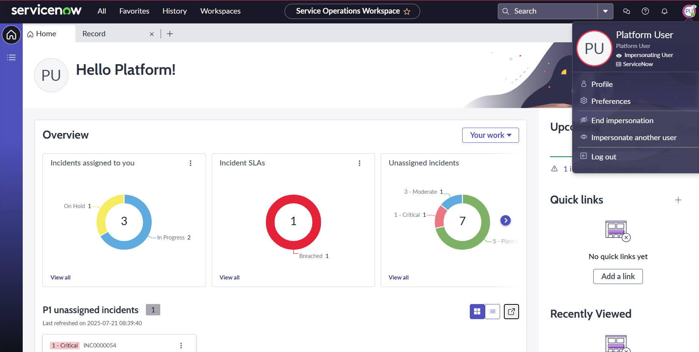
img 1: Impersonating User

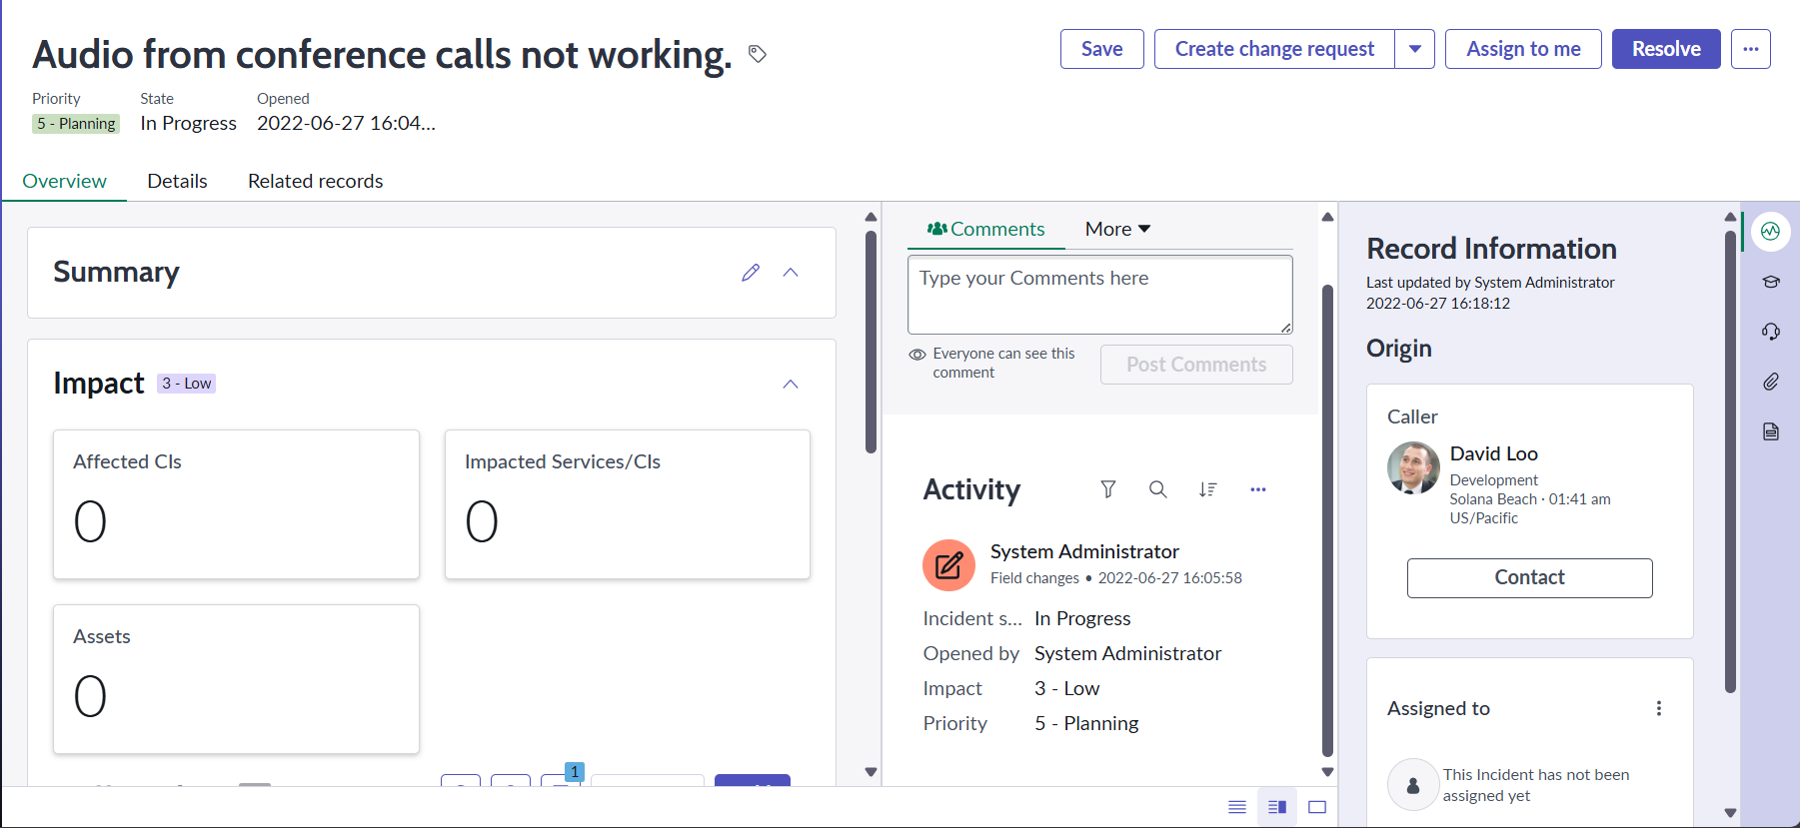
img 1:Dashboard

9. CONCLUSION
My month-long internship at ServiceNow Solutions has been much fun. I have closed the gap between academic theory and industry practice thanks to my practical experience with the ServiceNow platform. From the fundamentals of platform navigation to core applications and automation concepts, the methodical approach to learning proved to be highly successful. I now possess technical expertise on a top enterprise platform and have a better grasp of the strategic significance of IT service management in a contemporary company. My ability to solve problems has improved due to my challenges, and I now have more faith in my capacity to pick up new skills and adjust to new technologies. The information and abilities I acquired during this internship will be invaluable to my future academic and professional endeavours. I appreciate the chance and will put what I've learned to use, thanks to ServiceNow Solutions.

Appendix
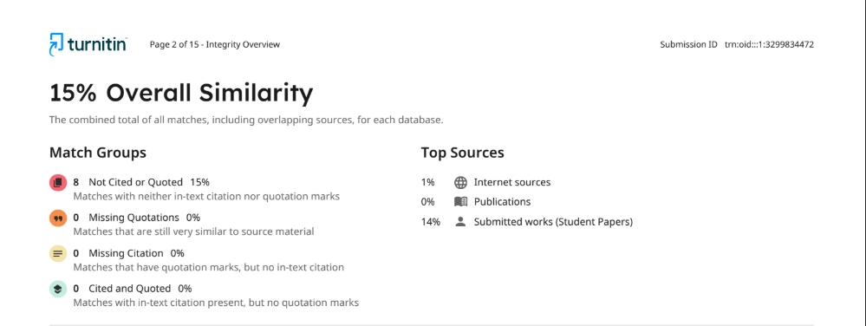
Plagiarism Report:

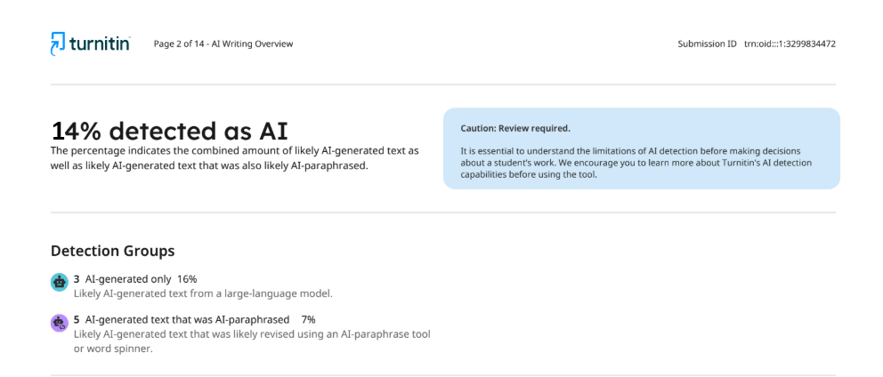
AI report:

